Benny Iko

8/4/2021

SWEN 603 9040 Modern Software Methodologies

RUP/AUP/EssUP methodologies critique

The Rational Unified Process (RUP) is an iterative software development process framework devised by Rational Software. It is an adaptable framework, as opposed to being a single prescriptive process. Also, it is notably the most renowned and extensively documented refinement of the Unified Process. When implementing RUP, the intention is for software teams and organizations to tailor the framework to meet their specific needs. There is a great deal of confusion that may arise due to the naming convention used by this and closely related software life cycles. For example, it is often impossible to say whether a refinement of a process was derived from UP or from RUP. As a result, the names tend to be used interchangeably. The name Unified Process is generally used to describe the generic process and elements which are common to most refinements. Additionally, it may be used to avoid potential trademark infringement issues; the Rational Unified Process and RUP are trademarks of IBM. Authors affiliated with Rational Software favor the name Rational Unified Process, while unaffiliated authors publish books with the moniker Unified Process.

The Rational Unified Process is a software process product which includes a knowledge base, sample artifacts and detailed descriptions for a variety of activities. RUP is based on a set of content elements, which describe what is to be produced, the necessary skills required, and an explanation of how development goals will be achieved. These building blocks include roles, work products, and tasks. Combining the experience base of companies led to the articulation of six best practices for modern software engineering: to develop iteratively, manage requirements, employ a component based architecture, to model software visually, to continuously verify quality, and to control changes. These best practices help customers improve the quality and predictability of software development efforts. The RUP has determined a project life cycle consisting of four phases: Inception, Elaboration, Construction, and Transition. The best practice of iterative development is easily identifiable and the key to the process; iterations of development lie within all of the phases. Moreover, each phase has a key objective and milestone that denotes the accomplishment of the objective. To minimize faults and increase productivity when designing a software project, it is imperative to always keep in mind the requirements set forth by users. Generation of a basic use case model, project plan, initial risk assessment and project description are sufficient here. In the Inception phase, the project is checked against requirements understanding as evidenced by the correctness of the primary use cases. Employing a component based architecture has noticeable benefits for a software project, as breaking down a complex project is unavoidable. For instance, this approach employs promotion of code reusability. Also, the ability to test individual components before integration is invaluable. Together, this is a big plus,as the two can be accomplished more easily through the use of OOP or object-oriented programming. The best practice of modeling software visually is evident throughout the evolution of the RUP, as well as its phases. The phases allow the process to be presented at a high level, similar to how a 'waterfall'-style project might be presented. The visualization of RUP phases and disciplines over time is referred to as the RUP hump chart.
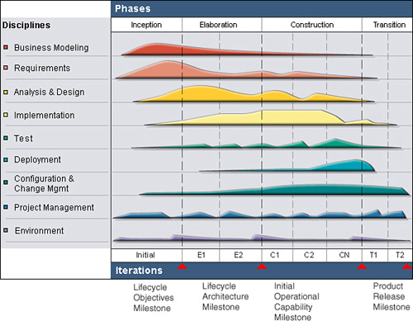

From 1996-2000, the methodology saw continued improvements of UML incorporated into the standard. With RUP, it is ideal to use diagrams to represent all major components, users, and their interaction. One way to accomplish this is with "UML", short for Unified
Modeling Language. As with any project, testing should be a major part of the project; it becomes heavier as the project progresses, but should be a constant factor in any software product creation. All software should be tested during each iteration; that is, unit, system, and load testing. The idea is: to test early, often, and realistically. This is accomplished via integrating and testing during each iteration. Test-driven development or TDD is a known best practice. Continuous integration is also useful, and both methods are also employed in another agile methodology, XP. Lastly, through disciplined configuration management and version control,
a change request protocol, and baselined releases at the end of each iteration, the management of change is implemented as a best practice in the Rational Unified Process.

Depending on your perspective, this life cycle may or may not include some undesirable traits. For instance, there are many details, and RUP phases are often incorrectly applied in a waterfall style. This widely adopted methodology is proven to scale to large or small projects. The following projects are examples of applied values and practices that characterize a UP project. It was used to create a Canadian Automated Air Traffic Control System, which took 10 years to develop, and was an L400 life-critical project. A small project includes the implementation of a point of sale software named QUICKcheck. This project took a year to develop, using Java technologies.

Creators of the UP did not intend the process to be applied or adopted in a rigid or heavyweight manner. The UP is easily combined with techniques from other methods. This explains the many different refinements of the life cycle. They view the UP as a suite of options to pick from, within the constraints of adopting its spirit and best practices. Agile Unified Process is a simplified refinement of the RUP, which describes an easy to comprehend approach to developing business applications using agile techniques. EssUP, invented by Ivar Jacobson, also improves upon the RUP. It is supported by a set of playing cards, and each card describes a practice.

